

**Key Facts**

* Open to parents of children aged 0-16
* 10 week course, 2 hours a week
* supports parents to think differently about their children’s behaviour and build more attuned relationships with them
* focuses on managing adults’ and children’s difficult feelings
* Open to all parents regardless of their situation who want to look at building deeper and meaningful relationships within the family

**Where does it come from?**

The Solihull Approach was first developed in Solihull in 1996 by health and care professionals in Solihull working with families in the community and a team of child psychologists and child psychiatrists led by Dr Hazel Douglas.

The Solihull Approach Model provides parents with a framework for thinking about children’s behaviour through the 3 key concepts: **containment, reciprocity and behaviour management**. These concepts can be useful to help children, adults and workers to analyse, understand and process emotions and anxieties that can be overwhelming

The programme focuses on the parent/child relationship. It aims to support parents in building positive, nurturing and responsive relationships with their children.

Research studies showed that there was a very significant reduction in parents’ anxiety.

**PARENTING GROUPS**

**The Solihull Approach – Parenting Programme**

**Topics:**

Attachment

Development of the brain

Child’s off age development

Recognising and responding to your own and child’s feelings

Parenting Styles

Play time – having fun together

Rhythm of interaction and sleep

Self -regulation and anger

Communication and attunment

**For more information contact:**

Adopt North East

Balliol Pembroke Wing

Chester Avenue

Longbenton

Newcastle upon Tyne

NE12 8QP

Tel: 01916435000

Email:

adoptnortheast@northtyneside@gov.uk

**www.adoptnortheast.org.uk**



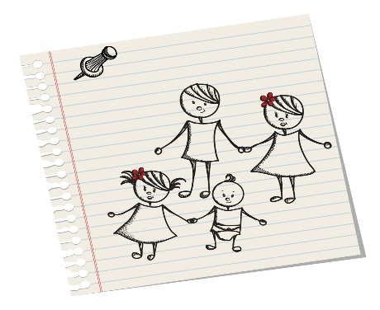

**What is it about?**

The Solihull Approach helps to enhance parent/child relationships. Activities are designed to encourage a reflective style of parenting that leads to more sensitive and effective parenting. Parents are also helped to understand how they can influence their relationship with their child through play. The group is designed to help parents identify their own objectives as an ongoing process during the course and would also be appropriate for parents of children with additional needs. There are several opportunities for parents to participate in activities which encourages them to experience different ways of communicating.

**What does it involve?**

The programme is designed to run for 2 hours per week over 10 weeks, and sessions covered include:

* How do you know what you and your child are feeling?
* Tuning in to your child’s developmental needs
* Having fun together
* Self-regulation
* Sleep and anger
* Different styles of parenting
* How to recover when things go wrong

The parents are supported in thinking about what the child is telling them through their behaviour, to support this approach the group programme does not start with behaviour management techniques, but rather helps build a solid foundation then the behaviour management techniques can be used effectively.

**Aims of the group**

* To promote understanding of children’s behaviour within context of development.
* To increase confidence and self-esteem in parent and child.
* To give parents a strategy for repair when things go wrong.
* To promote reflective, sensitive and effective parenting



***“I feel more relaxed with my child and have a better understanding. It helps knowing others have similar experiences and feelings as me. No-one was judgemental and I can reflect upon myself more”.*** Comment from parent.

Our PARENTING GROUP